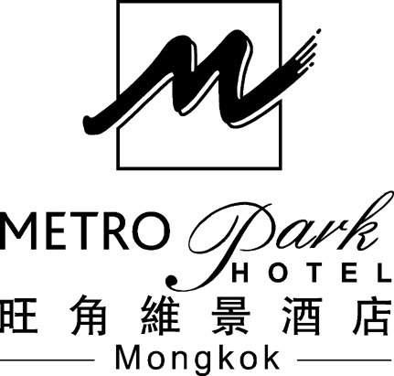 | 22 Lai Chi Kok Road, Mongkok, Kowloon, Hong Kong. (Exit C2 at the Prince Edward MTR station)  General Line : Tel. : (852) 2397 6683 Fax : (852) 2381 3768  Sales Office : Tel. : (852) 2397 9668 Fax : (852) 2397 7337  URL : http://www.metroparkhotelmongkok.com  E-mail : sales.hkmk@metroparkhotels.com

Accommodation Reservation Form
International Conference on Asymptotics and Special Functions
Liu Bie Ju Centre for Mathematical Sciences
City of University of Hong Kong
29 May – 4 June 2011

Name: |  | (First Name) |  | (Last Name)
 |  | (First Name) |  | (Last Name)

Arrival Date | : |  | Arrival Flight | : |  | Expected Arrival Time | :
Departure Date | : |  | Departure Flight | : |  | Expected Departure Time | :

Airport Shuttle Bus service (HK$100.00 per guest per trip) |  | Arrival |  | Departure

Tel: |  | Fax: |  | Email:

Special Package Rate
Superior Room |  | Room Rate |  | No. of rooms required
Room Only |  | HK $585.00
Room with 1 Breakfast |  | HK $640.00
Room with 2 Breakfasts |  | HK $695.00
Special request: |  |  | (subject to Hotel’s availability & confirmation)

The above rates are on per room per night basis, inclusive of 10% service charges.
The above rates are only applicable to the period of 29 May – 04 June 2011 both dates inclusive.

Guaranteed By: |  | Visa |  | Master |  | Diners |  |  | JCB |  |  | Amex
Credit Card Number:
Cardholder’s Name: |  |  |  |  |  |  |  | Expiry Date:

Your reservation has been guaranteed by the above credit card. Please notify the Hotel by 72 hours before the arrival if the reservation is no longer requested in order to avoid any late cancellation charges. Otherwise, one night room rate will be charged as penalty.

Terms of Payment
All charges will be settled by GUEST OWN ACCOUNT upon departure either by Cash or Credit Card only.

Date of Application: |  |  | Signature:

- All guests are required to book the Hotel rooms before 29 April 2011 through the following method:
- Fax | : | Please send the completed reservation form to our Hotel via below fax number:  Sales & Marketing Office at (852) – 2397 7337
- E-mail | : | Please contact us via below e-mails:  Ms Milly Wan (Assistant Sales Manager) : milly.wan@metroparkhotels.com  Ms Jessica Li (Account Manager) : jessica.li@metroparkhotels.com
- Telephone | : | Please contact us via below telephone numbers:  Ms Milly Wan (Assistant Sales Manager): (852) – 2397 9670  Ms Jessica Li (Account Manager) : (852) – 2397 9613
- Rooms are available on first-come-first-served basis & must be guaranteed by credit card.
- All booking are subjected to hotel's availability & confirmation. Please be advised to book earlier.
HOTEL USE ONLY
 | Confirmed |  | Rejected |  | Others

Confirmed By: |  | Signature: |  | Date:

